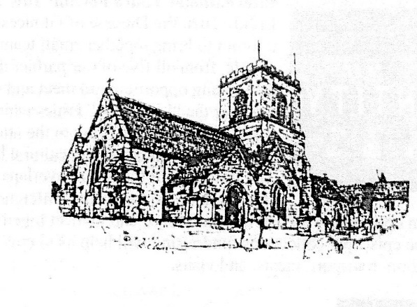to journey in faith and share God’s love
Welcome to our resource for a time of Prayer and Praise on the 2nd Sunday of Easter, for use while we are unable to meet as a Congregation during this lock-down period. Despite the need to stay at home, we hope that you will feel united with all who make up our Parish at this time – and with Christian people around the world. We join with them in praising God and praying for one another …we are never alone!
If possible, use this at the time you would normally join your fellow worshippers to be united with them.
Preparation – carefully and safely light your Easter Candle, and have your bible available (if anyone needs a Bible please phone David on 552926)
Reflect on the words as you sing or say
Be still for the presence of the Lord,
The Holy One, is here.
Come, bow before him now
With reverence and fear.
In him no sin is found,
We stand on holy ground.
Be still, for the presence of the Lord,
The Holy One, is here.

The Collect collecting us together for the 2nd Sunday of Easter

Almighty Father, you have given your only Son to die for our sins and to rise again for our justification; grant us so to put away the leaven of malice and wickedness that we may always serve you in pureness of living and truth; through the merits of your Son Jesus Christ our Lord. Amen

Pause to reflect on the malice and wickedness that we must put away…………..
Lord Jesus, you raise us to new life. Lord, have mercy.
Lord Jesus, you forgive us our sins. Christ, have mercy.
Lord Jesus, you feed us with the living bread. Lord, have mercy.

Bible Reading John 20. 19-31
Reflection Isolated as the disciples were, we need the faith of doubting Thomas that Jesus is “My Lord and my God”. This is the crux of our faith – we cannot see the Risen Jesus and touch Him, but we believe He is with us now in our isolation and fear. He does not allow us to wallow in self pity but says “As the Father sent me, so I send you” and breathing the Holy Spirit on those frightened disciples he transforms them into agents of love, signs of hope within our community. We have become resurrected people because of the resurrection of Jesus. Blessed are those who have not seen yet believe.

The renewal of Baptismal Vows

As we celebrate the resurrection of our Lord Jesus Christ from the dead, we remember that through the paschal mystery we have died and been buried with him in baptism. To follow Christ means dying to sin and rising to new life with him.
Therefore I ask:
Do you reject the devil and all rebellion against God?
I reject them.
Do you renounce the deceit and corruption of evil?
I renounce them
Do you repent of the sins that separate us from God and neighbour?
I repent of them.

In baptism, God calls us out of darkness into his marvellous light.
Therefore I ask:
Do you turn to Christ as Saviour?
I turn to Christ.
Do you submit to Christ as Lord?
I submit to Christ.
Do you come to Christ, the way the truth and the life?
I come to Christ.

May Almighty God deliver us from the powers of darkness, restore in us the image of his glory, and lead us in the light and obedience of Christ, Amen

Sing or say Breathe on me breath of God
Fill me with life anew
That as you love, so may I love
And do what you would do.

Breathe on me breath of God
Until my heart is pure;
Until my will is one with yours
To do and to endure.

Breathe on me breath of God
Fulfil my heart’s desire,
Until this earthly part of me
Glows with your heavenly fire.

Breathe on me breath of God
So shall I never die,
But live with you the perfect life
Of your eternity.
Our Prayers.

In joy and hope let us pray to the Father, saying Christ is risen.
That our risen Saviour may fill us with the joy of his glorious and life giving resurrection.
That isolated and persecuted churches may find fresh strength in the good news of Easter.
Christ is risen.
That God may grant us humility to be subject to one another in Christian love,,,,
That he may provide for those who lack food, work, or shelter….
That by his power war and famine may cease through all the world…..
Christ is risen.
That he may reveal the light of his presence to the sick, the weak, and the dying to comfort and strengthen them……..
That, according to his promises, all who have died in the faith of the resurrection may rejoice in eternal life……………….
That he may send forth the fire of the Holy Spirit upon his people, so that we may bear faithful witness to his resurrection.
Christ is risen.
Heavenly Father, who delivered us from the power of darkness and brought us into the kingdom of your Son: grant that, as his death has recalled us to life, so by his continual presence in us may raise us to eternal joy; through Jesus Christ our Lord. Amen
Christ is risen. He is risen indeed! Alleluia

Sing or say
Guide me O thou great redeemer
Pilgrim through this barren land;
I am weak, but thou art mighty;
Hold me in thy powerful hand:
Bread of heaven, bread of heaven,
Feed me now and evermore
Feed me now and evermore.

Open thou the crystal fountain,
whence the healing stream doth flow;
let the fiery cloudy pillar
lead me all my journey through;
strong deliv’rer, strong deliv’rer
be thou still my strength and shield,
be thou still my strength and shield.

When I tread the verge of Jordan,
bid my anxious fears subside;
death of death and hell’s destruction,
land me safe on Canaan’s side:
songs of praises, songs of praises,
I will ever give to thee,
I will ever give to thee.

Pray slowly the prayer our sisters and brothers have been taught by Jesus

Sing or say
(this hymn was written in the middle of the 100 years war with destruction all around)

O God our help in ages past
Our hope for years to come
Our shelter from the stormy blast
And our eternal home.

Under the shadow of thy throne
Your saints have dwelt secure;
Sufficient is thine arm alone,
And our defence is sure.

Before the hills in order stood
Or earth received her frame,
From everlasting thou art God
To endless years the same.

A thousand ages in your sight
Are like an evening gone,
Short as the watch that ends the night
Before the rising sun.

Time, like an ever rolling stream
Bears all its sons away;
They fly forgotten, as a dream
Dies at the opening day.

O God our help in ages past,
Our hope for years to come,
Be our defence while life shall last,
And our eternal home.

The Blessing

May Christ, who out of defeat brings new hope and a new future, fill us all with his new life; and the blessing of God, Almighty, the Father, the Son and the Holy Spirit be upon us all those we love and pray for this day and always. Amen

They say that laughter is the best medicine………………

A reminder that next Thursday 23^{rdh} is Saint George’s Day. Pray for our parish and wear a red rose if you go out.

Please print a copy of this and give to any member who does not have a computer.

