Jesus Heals…
Sunday 29th March – Lent 5

Holy Spirit increase your presence in us and in our home, so that we would both know and experience you in our worship now and throughout the week.

Sing: (click on the song title and it should open up and play in youtube)
Dear Lord and Father of Mankind

For words said that have been wrong and unkind.
Fill us with your Holy Spirit. Jesus forgive us.

For thoughts that have been false and impure.
Fill us with your Holy Spirit. Jesus forgive us.

For actions that have been harmful and hurtful to others.
Fill us with your Holy Spirit. Jesus forgive us.

We are assured of God’s forgiveness:

We are assured of God’s forgiveness:
Almighty God, who forgives all who truly repent,
Have mercy on us,
pardon and deliver us from all our sin,
Confirm and strengthen us in all goodness,
And keep us in life eternal;
through Jesus Christ our Lord.

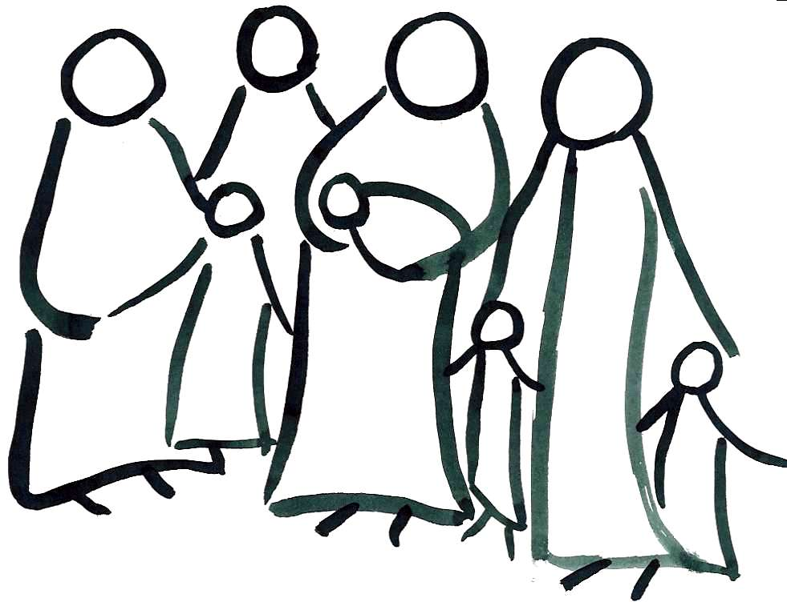
We are church.

Sing: (click on the song title and it should open up and play in youtube)
Be Thou My Vision

Bible Reading – John 11:1-17 (the reading is available to hear from our website)
Now a certain man was ill, Lazarus of Bethany, the village of Mary and her sister Martha. It was Mary who anointed the Lord with ointment and wiped his feet with her hair, whose brother Lazarus was ill. So the sisters sent to him, saying, “Lord, he whom you love is ill.” But when Jesus heard it he said, “This illness does not lead to death. It is for the glory of God, so that the Son of God may be glorified through it.”

Now Jesus loved Martha and her sister and Lazarus. So, when he heard that Lazarus was ill, he stayed two days longer in the place where he was. Then after this he said to the disciples, “Let us go to Judea again.” The disciples said to him, “Rabbi, the Jews were just now seeking to stone you, and are you going there again?” Jesus answered, “Are there not twelve hours in the day? If anyone walks in the day, he does not stumble, because he sees the light of this world. But if anyone walks in the night, he stumbles, because the light is not in him.” After saying these things, he said to them, “Our friend Lazarus has fallen asleep, but I go to awaken him.” The disciples said to him, “Lord, if he has fallen asleep, he will recover.” Now Jesus had spoken of his death, but they thought that he meant taking rest in sleep. Then Jesus told them plainly, “Lazarus has died, and for your sake I am glad that I was not there, so that you may believe. But let us go to him.” So Thomas, called the Twin, said to his fellow disciples, “Let us also go, that we may die with him.”

Now when Jesus came, he found that Lazarus had already been in the tomb four days. Bethany was near Jerusalem, about two miles off, and many of the Jews had come to Martha and Mary to console them concerning their brother. So when Martha heard that Jesus was coming, she went and met him, but Mary remained seated in the house. Martha said to Jesus, “Lord, if you had been here, my brother would not have died. But even now I know that whatever you ask from God, God will give you.” Jesus said to her, “Your brother will rise again.” Martha said to him, “I know that he will rise again in the resurrection on the last day.” Jesus said to her, “I am the resurrection and the life.^{[d]} Whoever believes in me, though he die, yet shall he live, and everyone who lives and believes in me shall never die. Do you believe this?” She said to him, “Yes, Lord; I believe that you are the Christ, the Son of God, who is coming into the world.”

It’s easy to doubt and question yourself. Did I turn the cooker off? Did I leave the light on? Did I lock the front door? Did God really mean I will be with you always? Is God really omnipotent and omnipresent? What we’re seeing around us certainly can make us doubt??
The story about Lazarus, makes us question and wonder about Jesus’s decision making. His friend v3“whom he loved” was dying, an immediate response was needed, but that’s not what we see. Which can make us question or even doubt ourselves and even our faith.
We have two very different responses from Lazarus’s sisters. A quick reminder of the Mary and Martha story (Luke10:38-42): Mary sat at Jesus’s feet listening to what he said, Martha was getting annoyed and distracted in the kitchen. In our story there is a reversal of roles, Martha goes running to meet him and declares her faith in Jesus, v22 “even now I know that whatever you ask from God, God will give you”.
Mary is very different, v20 ”Martha heard Jesus was coming, she went and met him, but Mary remained seated in the house”. Mary who sat at Jesus’s feet listening to him teach, she anointed his feet and wiped them with her hair, but now the disappointment she felt in Jesus was devastating for her. Her disappointment was stopping her meeting with Jesus. What disappointment do we have that is getting in the way of us meeting with Jesus, and receiving more of his peace, hope, help: more of his presence. It’s easy to think that because God didn’t answer my prayer, or I’m not healed yet, or my family are still suffering or why is Coronavirus still around, that God has forgotten us. We need to be reminded God is with us through the joys of life as well as the depths. Martha went to Mary and said v28, “the Teacher is here and is calling you. And when she heard it, she rose quickly and went to him”. We need to hold in faith that because we have doubts, and questions, we haven’t been forgotten, Jesus is calling our name.
In the middle of chaos and confusion it is difficult to keep the eyes of our faith on the light and hope: Jesus. That’s why we have faith: faith to trust in God’s timing and God’s ways, “we walk by faith, not by sight” 2Cor5:7. We walk on our journey, following the Jesus through the highs and lows of life, the days of clear blue skies of faith, and the fog of confusion and doubt.
To stop our lives being overtaken or overwhelmed by life’s circumstances: confusion, doubt or puzzlement. There is a process for allowing a healthy reflection and processing of our fears, our doubts, our joys. The process the bible gives us is PRAYER. The Psalms are full of healthy expressions of personal experiences and emotions. However much we know it is good for us, it is still difficult, which is why we should regard it as a discipline. Something we need to be deliberate and intentional about; athletes only improve by practicing and training. Yes, we can pray in the car on the way to work, and walking around the block; but is it our best? Why not start of by sitting down for 6mins (less time than it takes to drink a cup of tea), and in that 6mins spend 2mins thanking God, then 2mins asking God and then 2mins listening to what God has to say. Then next week make it 9mins – let’s train to be mighty prayer warriors!!

Sit & Reflect (Handel – Sarabande in D minor | if you find it helpful click the link and play the music, if you find it distracting just enjoy the silence).
Focus on a character, scene or part of the story and spend some time focusing on that aspect of the story, ask yourselves: why is it important to me? How does that apply to me today? How would Jesus help me today?

Declare aloud with boldness and confidence our faith:

Do you believe and trust in God the Father,
source of all being and life,
the one for whom we exist?
I believe and trust in God.

Do you believe and trust in Jesus, God the Son,
who took our human nature,
died for us and rose again?
I believe and trust in Jesus.

Do you believe and trust in God the Holy Spirit,
who gives life to the people of God
and makes Christ known in the world?
I believe and trust in the Holy Spirit.

This is our faith.
We believe and trust in one God,
Creator, Redeemer, Sustainer.

We pray for the world, the church, and people we love...
For the health and well-being of our nation,
that all who are fearful and anxious
may be at peace and free from worry:
Lord, hear us,
Lord, graciously hear us.

For the isolated and housebound,
that we may be alert to their needs,
and care for them in their vulnerability:
Lord, hear us,
Lord, graciously hear us.

For our homes and families,
our schools and young people,
and all in any kind of need or distress:
Lord, hear us,
Lord, graciously hear us.

For a blessing on our local community,
that our neighbourhoods may be places of trust and friendship,
where all are known and cared for:
Lord, hear us,
Lord, graciously hear us.

We commend ourselves, and all for whom we pray,
to the mercy and protection of God.
Merciful Father,
accept these prayers
for the sake of your Son,
our Saviour Jesus Christ.
Amen.
Protect, support and sustain all those working in our local hospitals, care homes and pharmacies, and their families. Give them the peace, strength and comfort they need at the moment to treat and nurse all those in their care.
Lord in your love and power.
AMEN.

Our Father in heaven,
hallowed be your name,
your kingdom come,
your will be done, on earth as in heaven.
Give us today our daily bread.
Forgive us our sins
as we forgive those who sin against us.
Lead us not into temptation
but deliver us from evil.
For the kingdom, the power,
and the glory are yours
now and forever. Amen.

Sing: (click on the song title and it should open up and play in youtube)
Praise my soul the king of heaven.

Numbers 6:24-26 The Lord bless you and keep you; the Lord make his face to shine upon you and be gracious to you; the Lord lift up his countenance upon you and give you peace.

Until we can come together in worship & witness: be strong in the Lord & in his mighty power. (Eph6:10)
– AMEN?

Notices:
Janes Pantry 01452 300326 are offering local deliveries for their breads, cakes etc.
ISingPop: if you have children at Primary School they may enjoy this YouTube channel. It’s fun, engaging content to help your children explore their faith. (I have worked with them on several occasions and they are really good).
Foodbank: - please use the supermarket collection points while the church office is closed, and our movement is limited.

